Consuming on-premise data in CAP application.
1.Go to File and select New Project.
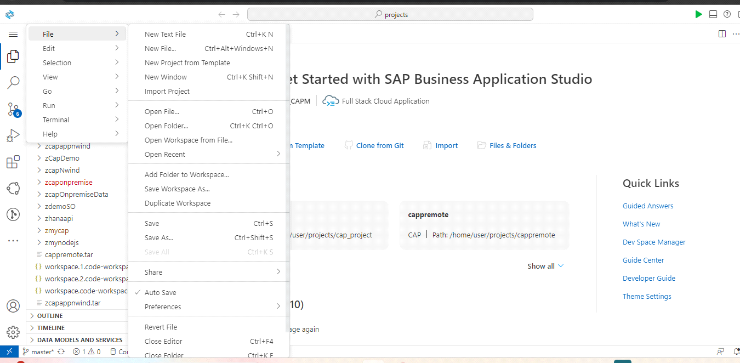
2.Select CAP Project and click Start.
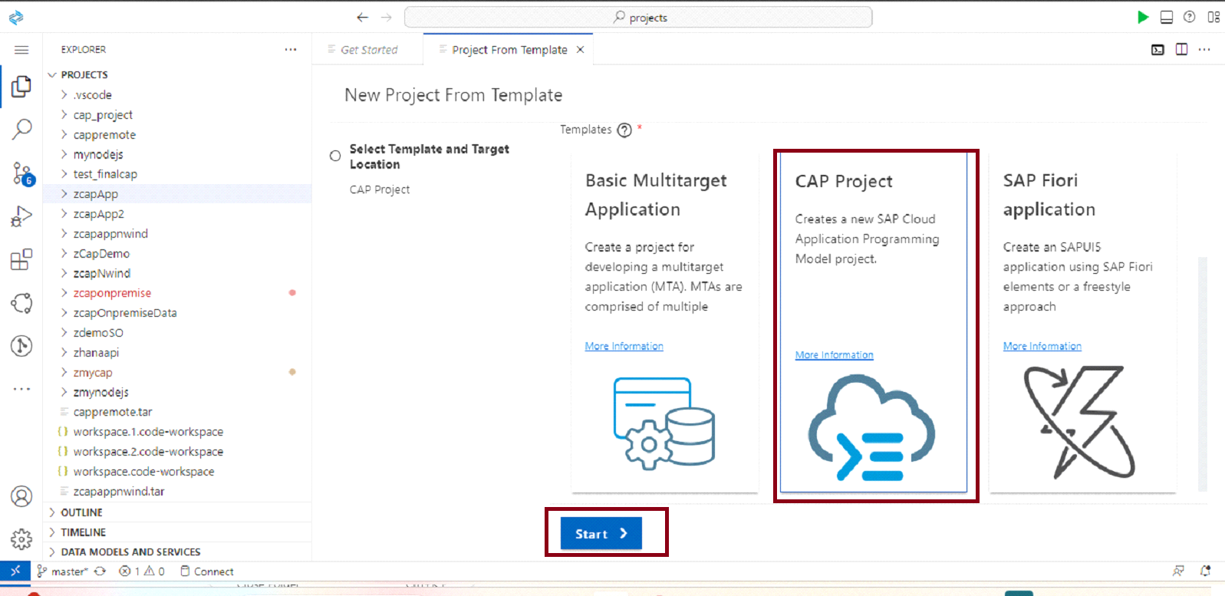
3.Provide your cap application name and click Finish.
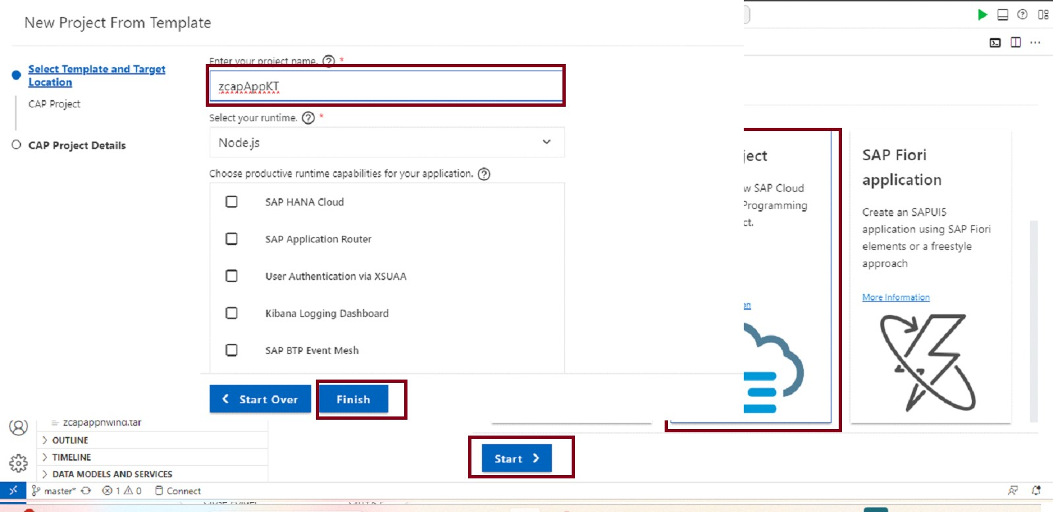

4.Now open your cap application terminal.
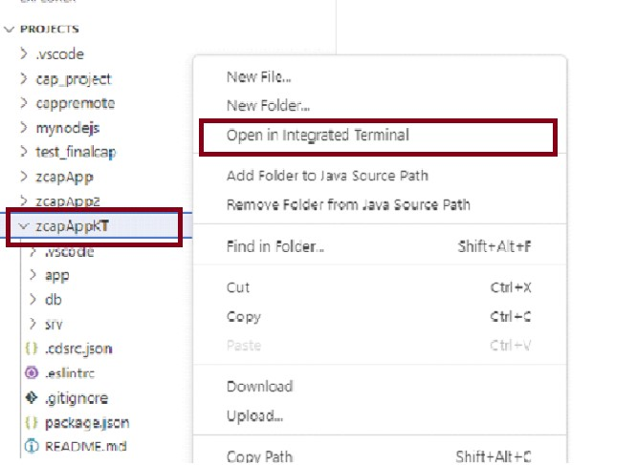

5.Now run the following commands.
i.npm install
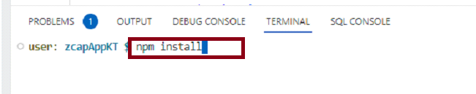
6.Now run the following command.
i.cds add mta
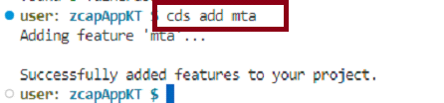
7.Now Consume your respective service from service center through
below screenshots.
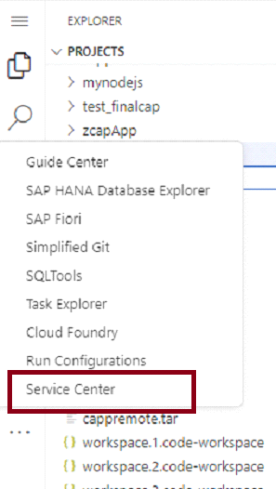

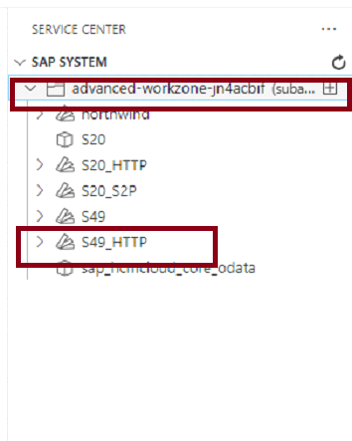

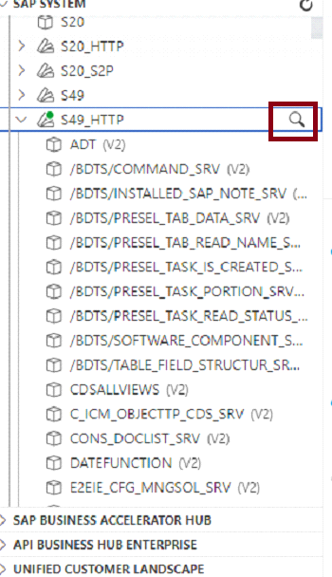
8.After selecting your service .Go to Service actions and select as shown.
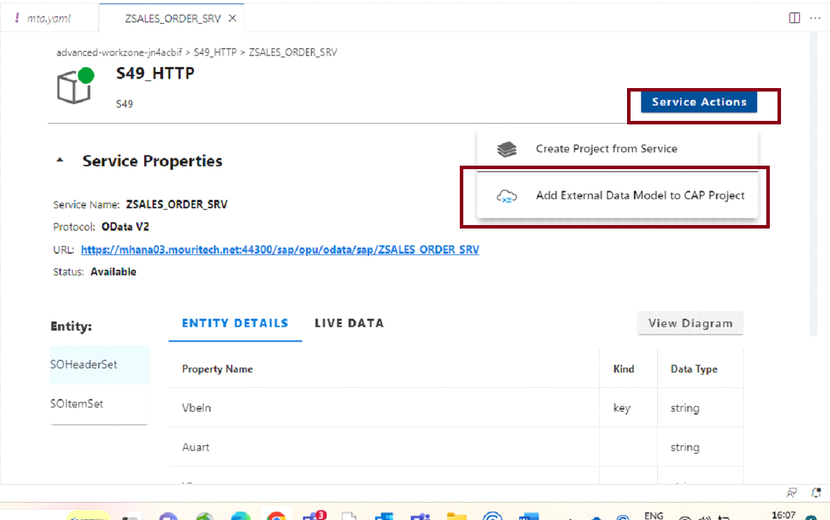
9.Pease select your cap application from below and provide the details asked for.
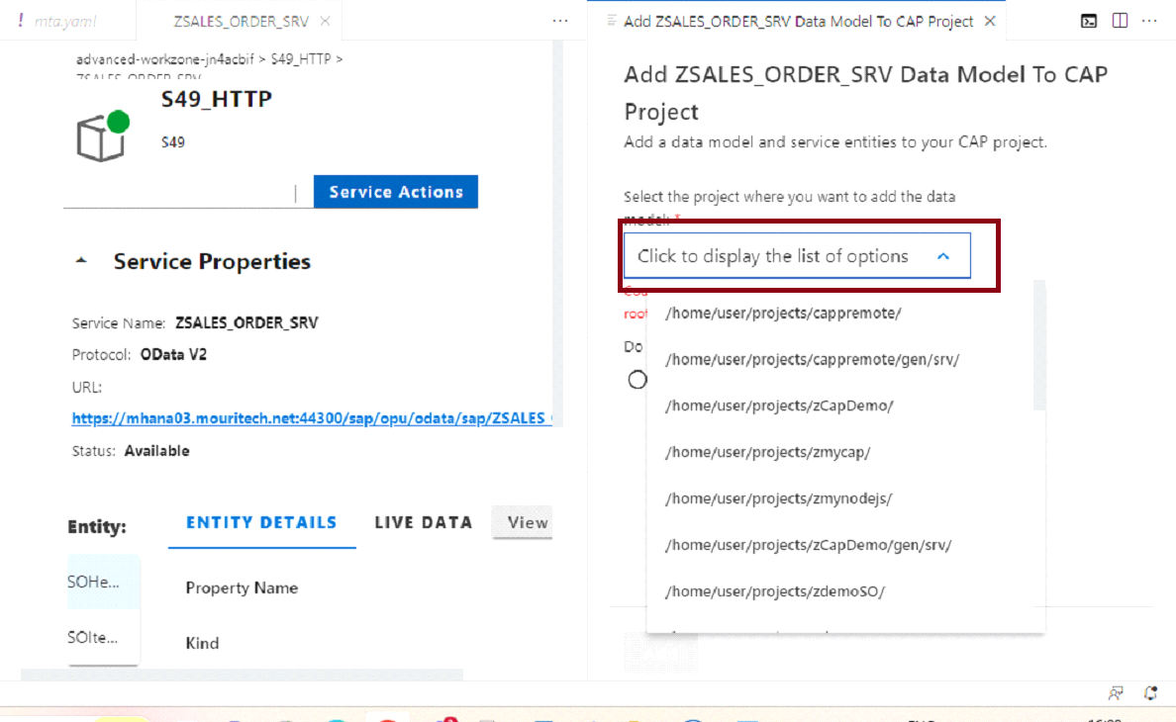

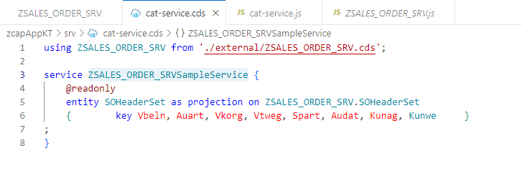

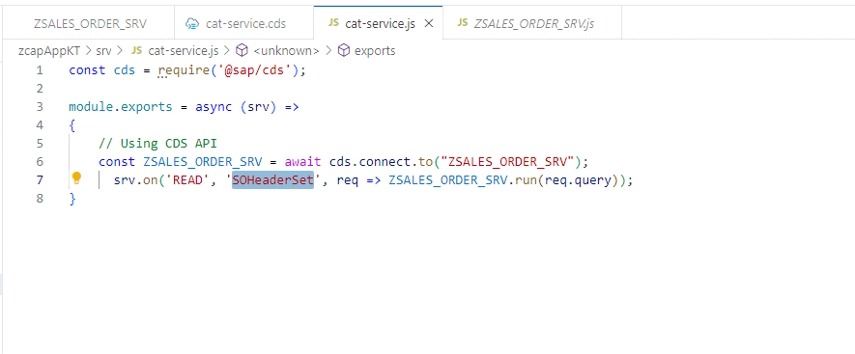
10.In order to create a relation to cloud Foundry.Plz provide the below command and Your credentials as asked.
Cf login
Shravanr.in@mouritech.com
Fioriui5@12345
Mouritech POC AdvanceZone

11.After providing your details please select "1" if you are using trail account and "2" if you are using Mouritech_adv_workzone.
12.Now run the following command inorder to add xsuaa,destination and connectivity.
i.cds add xsuaa,destination,connectivity --for production.
13.After running the above command please observe the changes in mta.yaml file.(Observe changes in resources and requires)
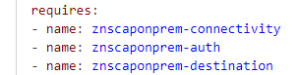

14.Now remove that below org and replace the "ZPoDetails" with your application name.
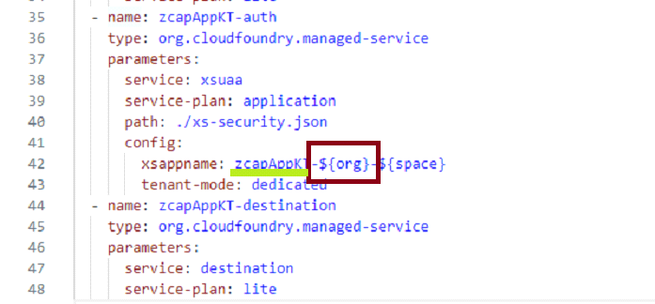
15.Now run the following commands to set up Destination,Connectivity and Authentication in mta.yaml file.
To Add Destination in MTA.YAML File to enter below command in git bash:(Note:Change "ZPoDetails" below with your cap application name)
cf create-service destination lite ZPoDetails-destination
cf create-service-key ZPoDetails-destination ZPoDetails-destination-key
cds bind -2 ZPoDetails-destination
For Connectivity:
cf create-service connectivity lite ZPoDetails-connectivity
cf create-service-key ZPoDetails-connectivity ZPoDetails-connectivity-key
cds bind -2 ZPoDetails-connectivity
For XSUA Authentication:
cf create-service xsuaa application ZPoDetails-xsuaa
cf create-service-key ZPoDetails-xsuaa ZPoDetails-xsuaa-key
cds bind -2 ZPoDetails-xsuaa
16.Paste the below code in MTA.yaml file "modules" after "requires" and change "ZPoDetails" with your application name.
- name: ZPoDetails-destination-content
type: com.sap.application.content
requires:
- name: ZPoDetails-destination
parameters:
content-target: true
- name: ZPoDetails_html_repo_host
parameters:
service-key:
name: ZPoDetails_html_repo_host-key
- name: ZPoDetails-auth
parameters:
service-key:
name: ZPoDetails-auth-key
parameters:
content:
instance:
destinations:
- Name: managedapprouter_ZPoDetails_html_repo_host
ServiceInstanceName: ZPoDetails-html5-app-host-service
ServiceKeyName: ZPoDetails_html_repo_host-key
sap.cloud.service: managedapprouter
- Authentication: OAuth2UserTokenExchange
Name: managedapprouter_ZPoDetails-auth
ServiceInstanceName: ZPoDetails-xsuaa-service
ServiceKeyName: ZPoDetails-auth-key
sap.cloud.service: managedapprouter
existing_destinations_policy: ignore
build-parameters:
no-source: true
17.Now paste the below code in "resources/destination/after parameters"
config:
HTML5Runtime_enabled: true
init_data:
instance:
destinations:
- Authentication: NoAuthentication
Name: ui5
ProxyType: Internet
Type: HTTP
URL: https://ui5.sap.com
- Authentication: NoAuthentication
HTML5.DynamicDestination: true
HTML5.ForwardAuthToken: true
Name: srv-api
ProxyType: Internet
Type: HTTP
URL: ~{srv-api/srv-url}
existing_destinations_policy: update
version: 1.0.0
18.Now paste the below code in (resources/destination/after parameters)after "service-plan: lite"
requires:
- name: srv-api
19.Now run the following command to add app router for configuration.
i.cds add approuter --for production
20.Now provide the below code in (resources/auth/parameters/after 'service: xsuaa').
(Note:Replace "ZPoDetails" with your application name)
service-name: ZPoDetails-xsuaa-service

21.Now take a Fiori app.From New Project from template
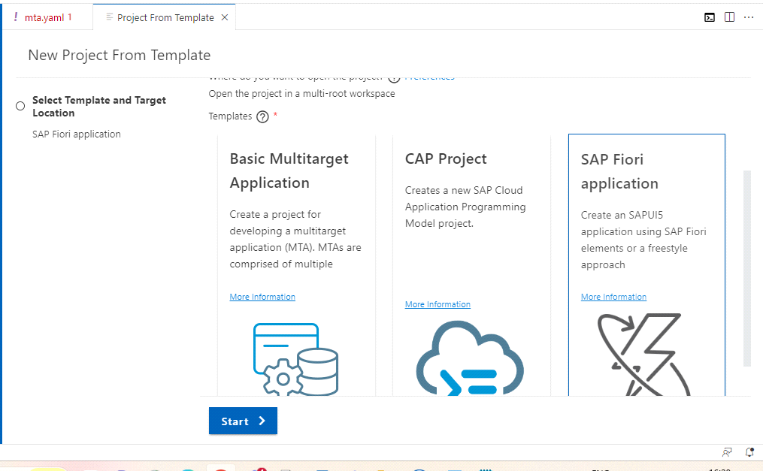
22.And select Deperecated template and select Worklist application.

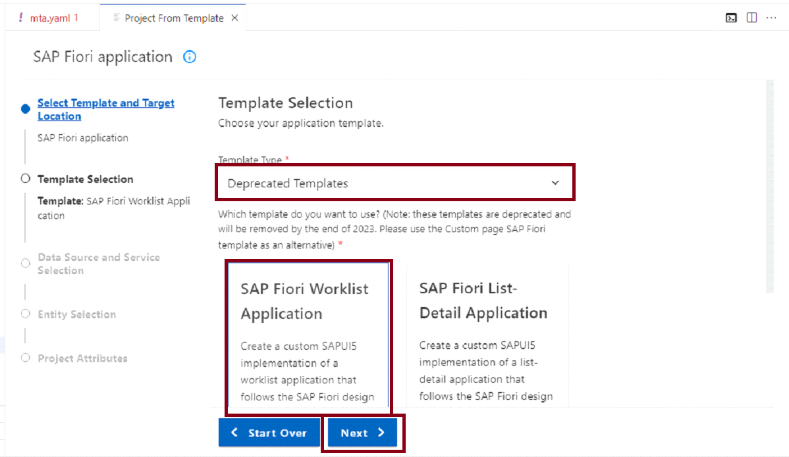

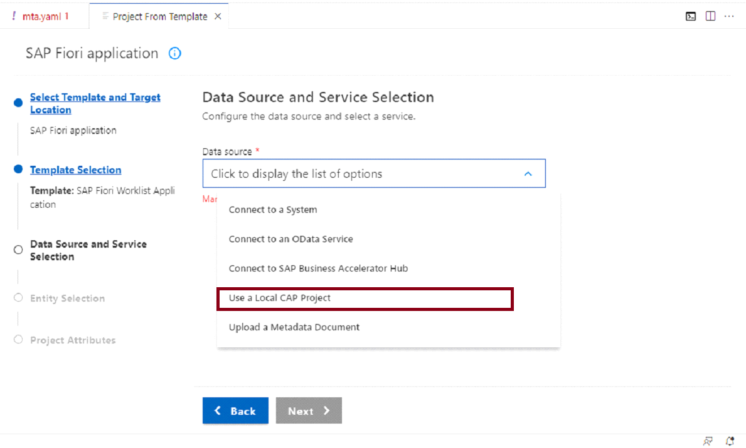

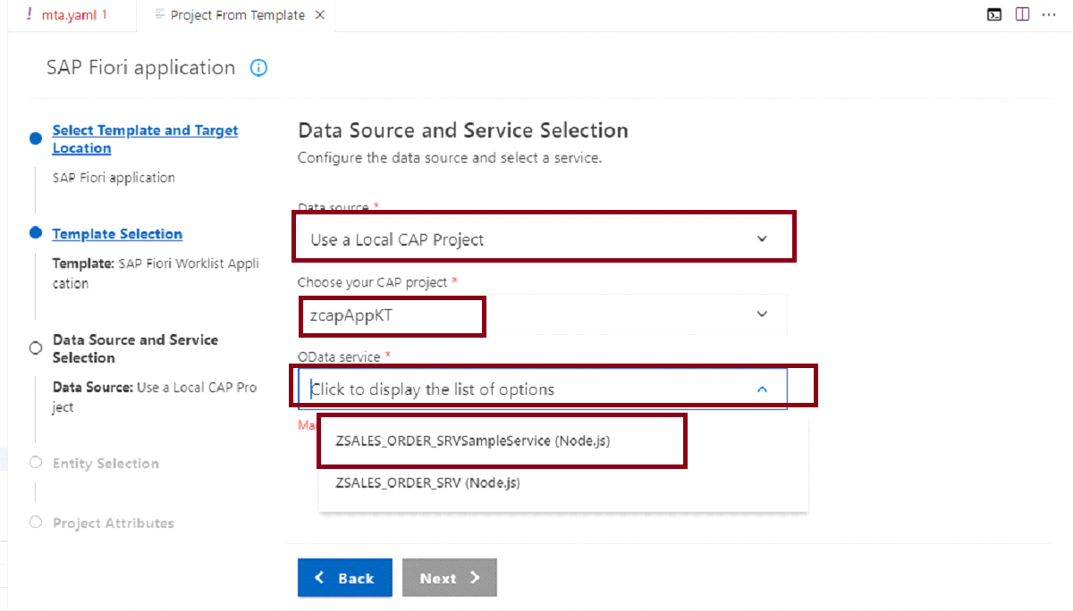

23.Now provide your entity and field details and select Next.

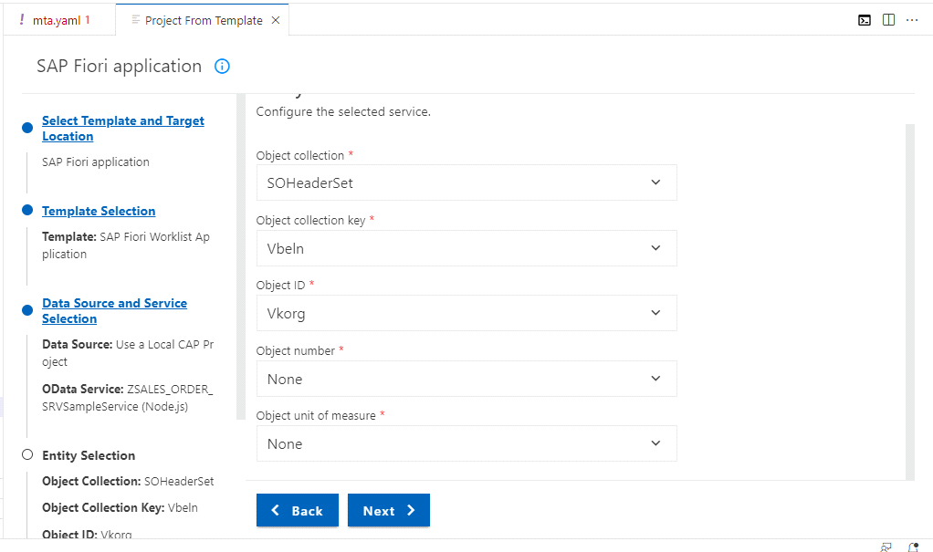
24.Select Add Deployment to "No" and click finish.
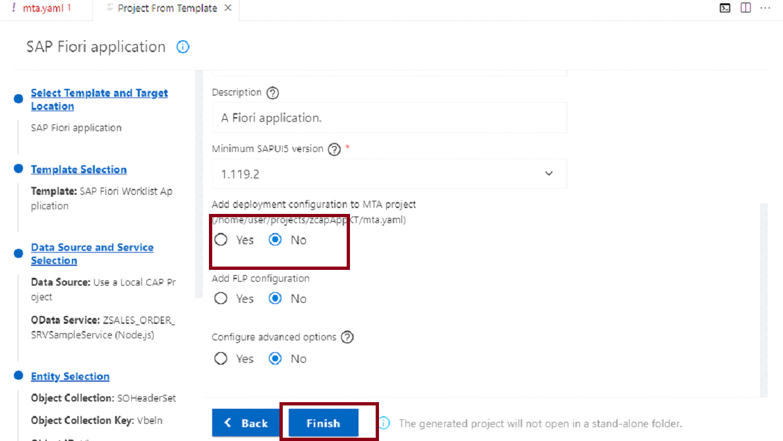

25.Now run the following command in the fiori app.
i.npm install --global @sap/ux-ui5-tooling
ii.npm install --global @sap/generator-fiori
iii.fiori add deploy-config cf
After running the above command it will ask for destination name .Please select srv-api.

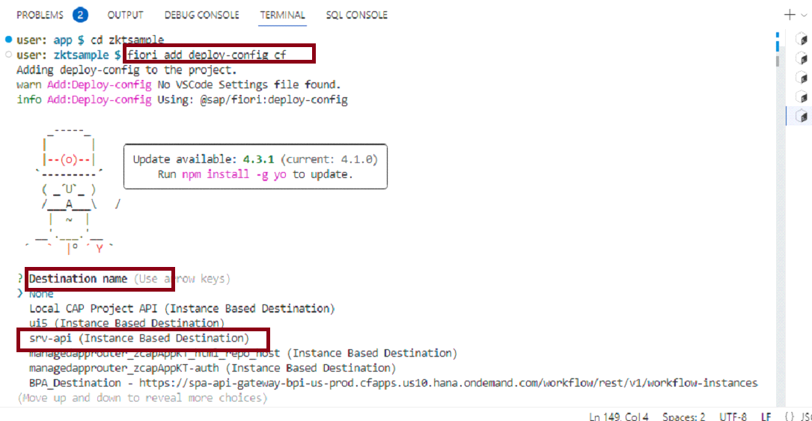
26.And select "y" for deployment configuration.

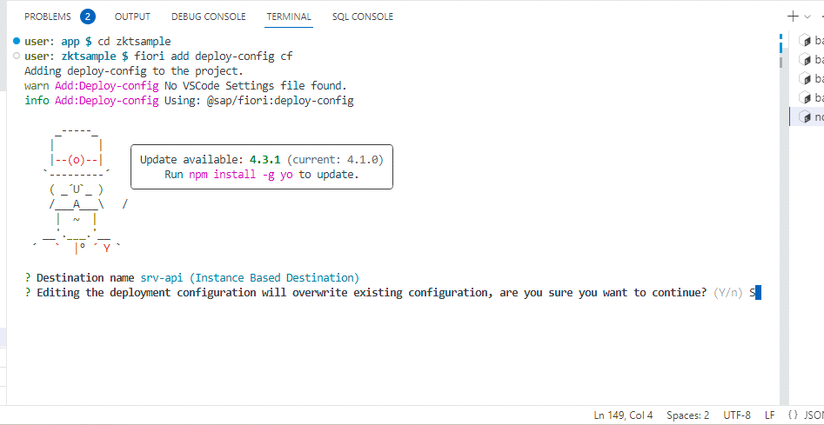
Now run the below commands in cap application terminal.
27.npm install @sap-cloud-sdk/http-client
npm install @sap-cloud-sdk/resilience
npm install @sap/cds-odata-v2-adapter-proxy
npm install @sap-cloud-sdk/http-client @sap-cloud-sdk/util

28.Now In mta.yaml file.Please do the necessary changes for htmp repo host in resources.
(Change znscaponprem with your appication name)
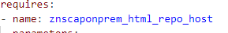

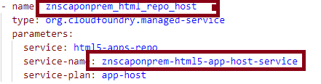

30.Now run the following command
i.mbt build
31.After running the above command mta_archives is created.
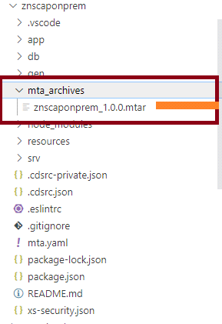
32.Now right click on .mtar file in mta_archives and select Deploy MTA Archive.
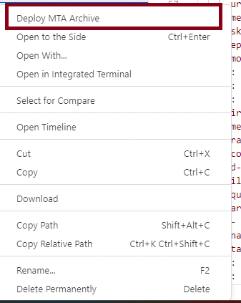
33.Now the application is Deployed Successfully.
34.Now go to btp cockppit and select HTML5 Applications
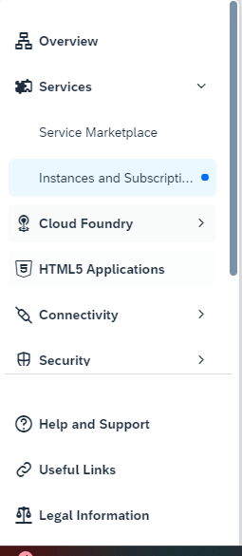
35.And search your appliation with the name space you provided while creating Fiori app along with your Fiori application name.

